FCPTLab4
Task 1: Create a News Article of 200 Words
Engineering students
develop robotic arm
It meets the basic daily requirements of an amputee
SPECIAL CORRESPONDENT  KOCHI  Five engineering students of Toc H Institute of Science and Technology at Arakunnam near here have come up with an Electromyography (EMG) controlled prosthetic arm.  The students - Mereena Baby, Aysha Zenab Kenza, Nikitha Sajan, Lakshmi Mohan, and Sharon Alex - are in the final year of their B.Tech Computer Science programme.  A release issued by the college claimed that the robotic arm would meet the basic daily requirements of an amputee, even though it lacked advanced features.  The prosthetic arm is priced at ₹2 lakh while those with advanced features cost anywhere between ₹15 lakh to ₹25 lakh, which is out of the reach of the common man, it said.  The students said that the Myo-armband interprets the electric signals produced as a result of the | 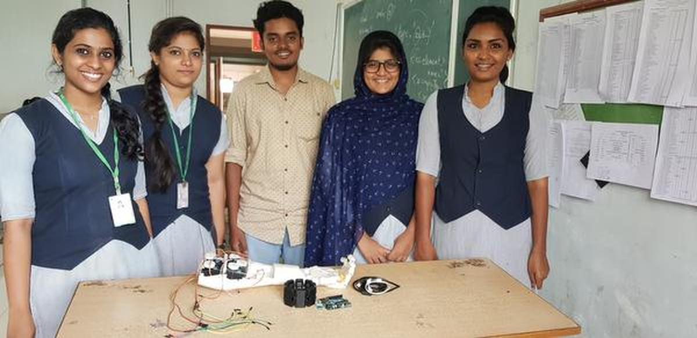  Students of Toc H Institute of Science and Technology,  Arakunnam, with the Electromyography-controlled  prosthetic arm that they developed.
  muscle movements and converts them into accurate hand gestures. They are then read by a micro-controller through a Bluetooth dongle.  Server motors  Based on those signals read, an appropriate number of server motors are rotated to move the prosthetic | limb, they said.  The release said that the product could be made faster and easier by using advanced technologies such as artificial intelligence.  The students expressed the hope that they would get support from investors to take the product to users.

Task 2: Create an Index
Index
Note: italic page numbers indicate specific methods, whilst bold page numbers indicate major sections on the subject.
Abraham Maslow 10 | argument 110
acceptance 138, 228, 229 | Aristotle 250
accepting 27 | arousal 25, 27, 114, 131, 210
action 132, 261 | as if 233
active care 188 | Asch, Solomon 73
active listening 176 | Ashby, Ross 38
advocate 242 | asking 235
affirmation 246 | aspirations 192
agreeableness 57 | assertion 217
aha 81 | association 72
aim inhibition 209 | assonance 118
alignment 18, 61, 92, 187 | assumption 217
alliteration 118 | assumptions 233
alternatives 104, 106, 111 | attention 10, 86, 95, 132, 210, 229, 232
amplification 210 | attitude 128, 129
anadiplosis 118 | attraction 54
analogy 118 | attribution 31
anaphora 118 | authority 218
anger 23, 97 | availability heuristic 73
answering 235 | avoidance 54, 209
anticipation 23, 97, 230 | bad for you 62
antithesis 118 | behaving 31
281

Task 3: Write the Math Equation Given Below
$$x=\frac{-b±\sqrt{b^{2}-4ac}}{2a}$$

Task 4: Create a Bibliography
Bibliography
Books
[B2] Willian F. Egan. Phase-Lock Basics. 1st edition. New York: John Wiley & Sons, 1998, pages 3–4 (cited on page 1).
[B3] Floyd M. Gardner. Phaselock Techniques. New York: John Wiley & Sons, 2005, pages 6–28 (cited on page 1).
Articles
[A1] John Doe. “Synthesizer Modulation”. In: (June 1979) (cited on page 1).
[A4] Me. “Lock Time Performance”. In: (June 1990) (cited on page 1).

